Resident and Student Poster Session at the MSA
Residents and students, present your work at the Missouri Society of Anesthesiologists
April 17-19th, 2020 Annual Meeting!
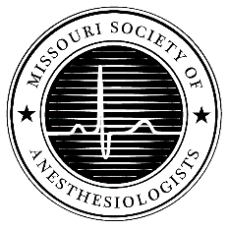

Poster categories include:
Case Presentations
Research/ Quality Improvement Projects

To secure a board for presentation, email: marshalljm@health.missouri.edu by March 15th, 2020 with a brief abstract.

Poster submission details:
Please submit an abstract limited to one page- describing the case presentation, quality improvement project, or research project by March 15th, 2020. This should be submitted as a Word document or PDF. Please include the name of your faculty mentor, all poster authors, your academic institution, and the poster category.
All posters must be printed prior to arrival to the MSA meeting. The poster must fit on a board 36 inches wide by 24 inches tall (3’ x 2’) board. There is no onsite printing service for posters at the MSA meeting. Tacks will be provided to secure the poster to the presentation board.
Please register for the meeting at: https://www.msahq.com/msa2020
The poster presentation session will occur:
Saturday April 18th, 2:00-2:30pm Ritz Carlton, St. Louis
5 Minutes for Presentation, followed by Proctor Questions
Posters should be in place on the presentation boards by 1:30pm, and encouraged to remain in place Saturday afternoon for attendees to review. Posters will be removed at the end of the formal lectures on Saturday afternoon. Presenters will be notified of awards for each category after the meeting.

Example Abstract Format:
Authors:
Title:
Institution:
Poster Category:
Brief Abstract: A figure, table, or image may be included for research posters.

Jointly provided by:
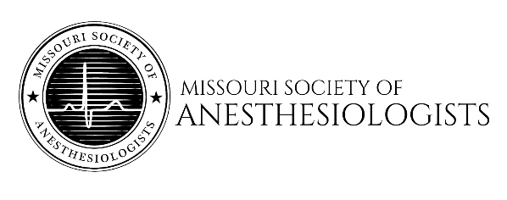

This activity has been planned and implemented in accordance with the accreditation requirements and policies of the Accreditation Council for Continuing Medical Education (ACCME) through the Joint Providership of the American Society of Anesthesiologists and the Missouri Society of Anesthesiologists. The American Society of Anesthesiologists is accredited by the ACCME to provide continuing medical education for physicians.
The American Society of Anesthesiologists designates this live activity for a maximum of 9.25 AMA PRA Category 1 Credits™. Physicians should claim only the credit commensurate with the extent of their participation in the activity.
This activity contributes to the Part 4: Improvement in Medical Practice requirement of the American Board of Anesthesiology’s (ABA) redesigned Maintenance of Certification in Anesthesiology Program® (MOCA®), known as MOCA 2.0™ (up to 2.0 points).
Maintenance of Certification in Anesthesiology Program® and MOCA® are registered certification marks of The American Board of Anesthesiology®.

